

Course Title: | Fundamental of Data Engineering
Course Number: | COE848
Semester/Year (e.g.F2016) | W2022

Instructor: | Faezeh Ensan

Assignment/Lab Number: | 4
Assignment/Lab Title: | Manipulating Data

Submission Date : | March. 14. 2021
Due Date: | March. 14.2021

Student  LAST Name | Student  FIRST Name | Student Number | Section | Signature*
Chen | Rick | 500909131 | 02 | 

*By signing above you attest that you have contributed to this written lab report and confirm that all work you have contributed to this lab report is your own work. Any suspicion of copying or plagiarism in this work will result in an investigation of Academic Misconduct and may result in a “0” on the work, an “F” in the course, or possibly more severe penalties, as well as a Disciplinary Notice on your academic record under the Student Code of Academic Conduct, which can be found online at: http://www.ryerson.ca/senate/current/pol60.pdf
company
companyID(int) | companyName(string) | gameCount(int)
1 | Team Cherry Games | 1
2 | Yostar | 4
3 | HyperGryph | 2
4 | miHOYO | 5
5 | Cygames | 13
6 | SquareEnix | 138
7 | BANDAI NAMCO Entertainment | 78
8 | CD PROJEKT RED | 7
9 | Rockstar Games | 13
10 | SEGA | 179
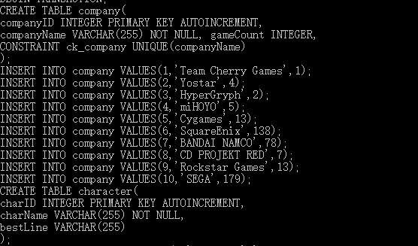

videoGame
VideoGameID | 1 | 2 | 3 | 4 | 5 | 6 | 7 | 8 | 9 | 10
gameName(string) | Dark Souls 3 | Arknights | Azur Lane | Genshin  Impact | Total War: Three Kingdoms | Sekiro | NieR: Automata | Granblue Fantasy: Versus | Red Dead Redemption 2 | Hollow Knight
rating(x/100) | 98 | 87 | 85 | 80 | 95 | 95 | 96 | 90 | 91 | 92
releaseDate(MMDDYYYY) | 04122016 | 05012019 | 08162018 | 04282020 | 05112019 | 03222019 | 03172017 | 03132020 | 11052019 | 02242017
DLCsCount | 2 | 0 | 0 | 0 | 11 | 0 | 1 | 53 | 0 | 2
Price(int) | 66 | 0 | 0 | 0 | 80 | 80 | 54 | 65 | 40 | 17
PlayedTime(hr) | 300 | 50 | 10 | 20 | 33 | 180 | 70 | 20 | 8 | 30
difficulty(1-10) | 10 | 6 | 3 | 5 | 9 | 10 | 7 | 6 | 5 | 3
genreID | 7 | 2 | 2 | 7 | 4 | 1 | 7 | 5 | 7 | 9
companyID | 7 | 3 | 2 | 4 | 10 | 7 | 6 | 5 | 9 | 1
platform | PC | mobile | mobile | PC | PC | PC | PC | PS4 | PS4 | PC
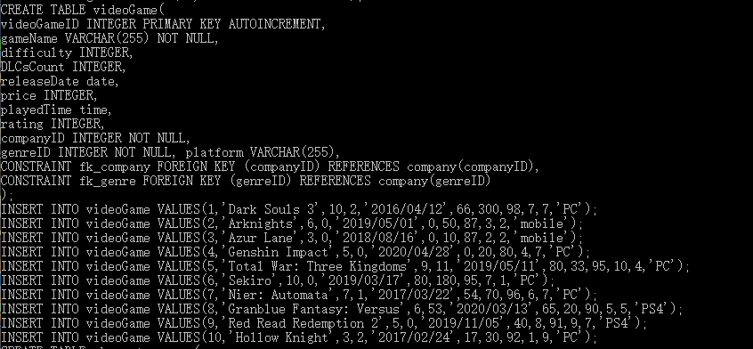

genre
genreID(int) | Type(string)
1 | RPG
2 | tower defense
3 | Shooters
4 | turn-based strategy
5 | Multiplayer online battle arena
6 | RPG
7 | ARPG
8 | sport
9 | action-adventure
10 | survival and horror
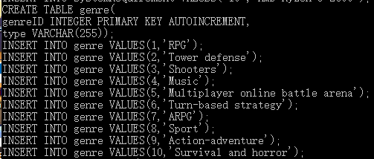

character
charID | charName | bestLine
1 | Siegward | Yhorm, old friend. I, Siegward of the Knights of Catarina, have come to fulfill my promise. Let the sun shine upon this Lord of Cinder!
2 | Patches | Every age, it seems, is tainted by the greed of men. Rubbish, to one such as I, devoid of all worldly wants! Hmmm, I dunno, maybe it's just the way we are. I'll stick you in my prayers. A fine dark soul, to you..
3 | Prince Lothric | This spot marks our grave, but you may rest here too, if you would like..
4 | Grimnir | Now is the hour for my right hand to be loosed from its proscription... May heaven and earth tremble, may darkness... err... umm... Uh, anyway! Now! I'm here to save you!!
5 | Pod 153 | Everything that lives is designed to end. They are perpetually trapped in a never-ending spiral of life and death. However, life is all about the struggle within this cycle. That is what ‘we’ believe.
6 | Kroos | Kokodayo
7 | Genichiro Ashina | If it is for the sake of preserving Ashina, I will seize any matter of herentical strength
8 | Isshin Ashina | Hesitation is defeat
9 | Owl | There Is No Shame In Losing One Battle. But You Must Take Revenge By Any Means Necessary!
10 | Pale King | No cost too great. No mind to think. No will to break. No voice to cry suffering. Born of God and Void.
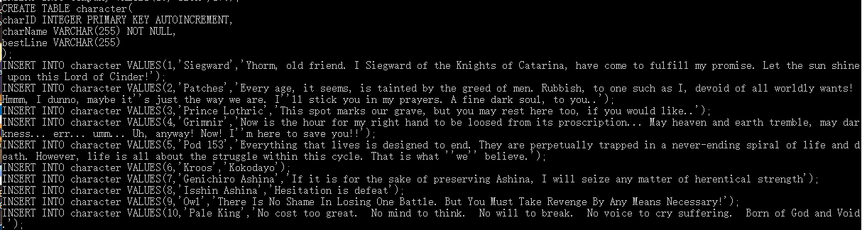

systemRequirement
sysReqID | OS
1 | Intel Core i5 2500
2 | Intel Core i3 2100
3 | AMD FX 6300
4 | Intel Core 2 Duo E5200
5 | Intel Core i5 6600
6 | Intel Core i5 3470
7 | Intel i7 3770
8 | AMD FX 4350
9 | AMD Ryzen 5 1400
10 | AMD Ryzen 5 2600
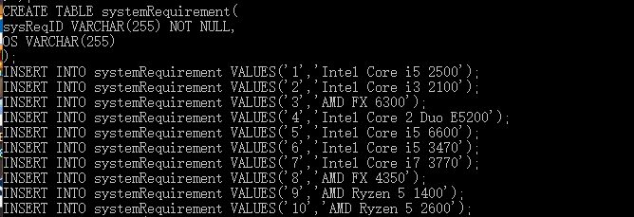

character_game
characterGameID | videoGameID | charID
1 | 1 | 1
2 | 1 | 2
3 | 1 | 3
4 | 8 | 4
5 | 7 | 5
6 | 2 | 6
7 | 6 | 7
8 | 6 | 8
9 | 6 | 9
10 | 10 | 10
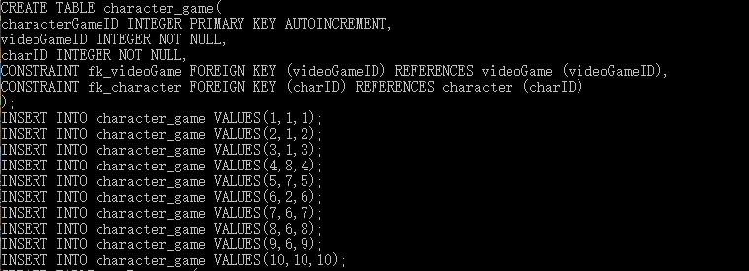

sysReq_game
sysReqGameID | videoGameID | sysReqID
1 | 1 | 2
2 | 1 | 3
3 | 4 | 1
4 | 4 | 6
5 | 5 | 5
6 | 6 | 2
7 | 7 | 2
8 | 8 | 8
9 | 8 | 6
10 | 10 | 4
11 | 5 | 10
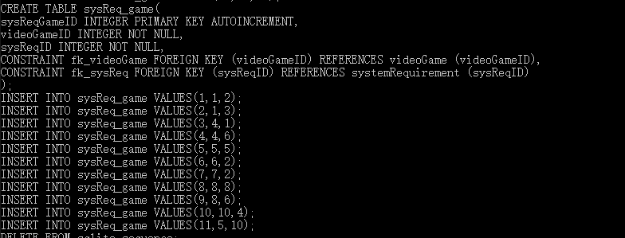

Queries:
- The total number of hours I played the video games
- Who are the characters from Dark soul 3?
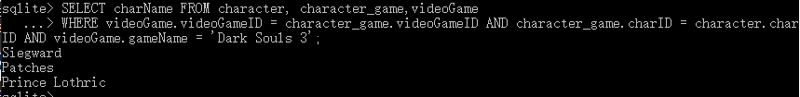
- What is the name of the game I played the most
- What is the type of the video game I played the most?
- What is the total amount of money I spent on the game?

- The list of OS required for video games: Sekiro?

- Which game is the most expensive game I bought?

- How many video games have I played on PC?


- Which game has the highest rating?


